[Type of article]
Research article
[Area or Content of science]
Physics
[Title]
An introduction to prepare manuscript for submission in SNRUJST
[Authors and Address]
First Author^{1, 2}, Second Author^{1, 2}, Last Author^{1, 2}
¹SNRUJST, Sakon Nakhon Rajabhat University, Sakon Nakhon, 47000 Thailand
²Research and Development Institute, Sakon Nakhon Rajabhat University, Sakon Nakhon, 47000 Thailand
[List of tables]
Table 1 Variation of X and Y.
[List of Figures]
Fig. 1 Example graph exhibits resolution 300 dpi.
Fig. 2 The relation between Y (a) and Y2 (b) with X.

An introduction to prepare the manuscript for submission in SNRU JST
First Author^{1, 2}, Second Author^{1, 2}, Last Author^{1, 2, *}
¹SNRUJST, Sakon Nakhon Rajabhat University, Sakon Nakhon, 47000 Thailand
²Research and Development Institute, Sakon Nakhon Rajabhat University, Sakon Nakhon, 47000 Thailand
*Corresponding Author: t_seetawan@snru.ac.th
Abstract
Text.....................................................................................................................................................................................................................................................................................................................................................................................................................................................................................................................................................................................................
Keywords: Text; Text; Text; Text; Text; Text

1. Introduction
Text………………......……………. [1] Text……….……………………………………………….
……………………… [2, 3] Text……………………..………………………………..……………….
………………………………………………………………………. [4 – 6] Text……………………..
…….. [4, 5, 7, 8] Text…………………………………………………………………………………...
…………………………………………………… [1, 5 – 9]

2. Materials and methods
Text........................................................................................................................................................................................................................................................................................................................................................as show in equation (1);
(1)

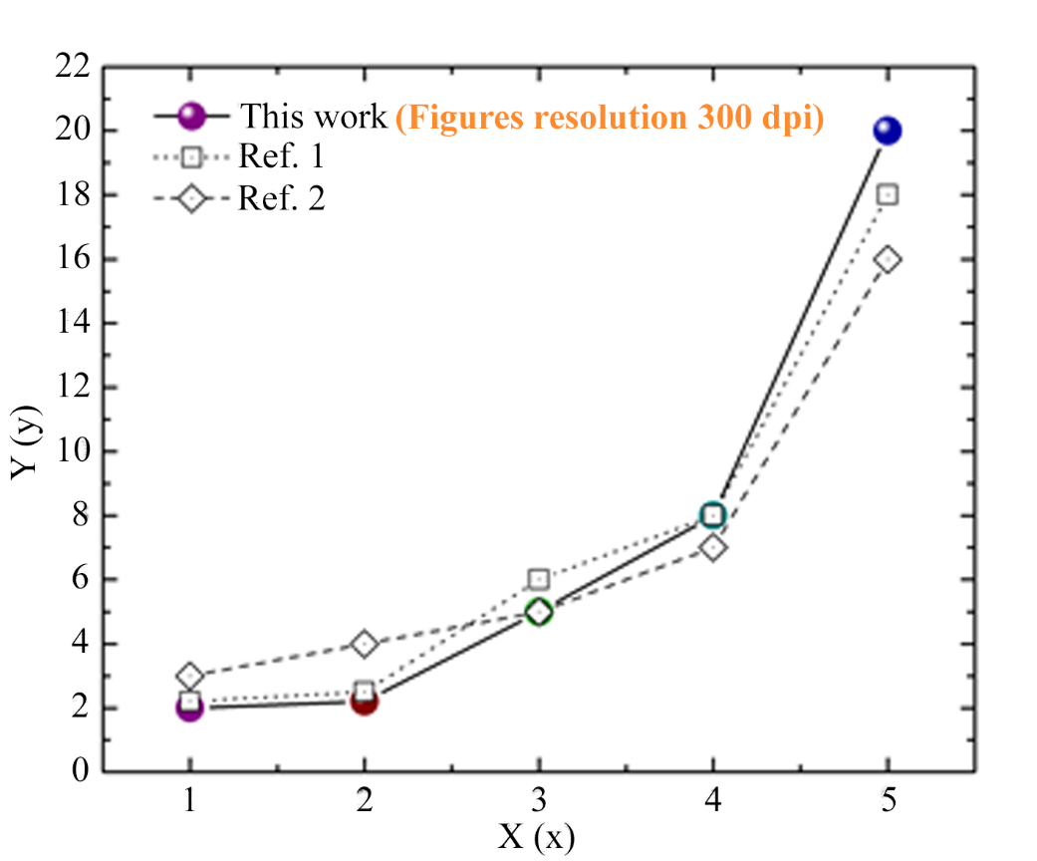
Fig. 1 Example graph exhibits resolution 300 dpi.
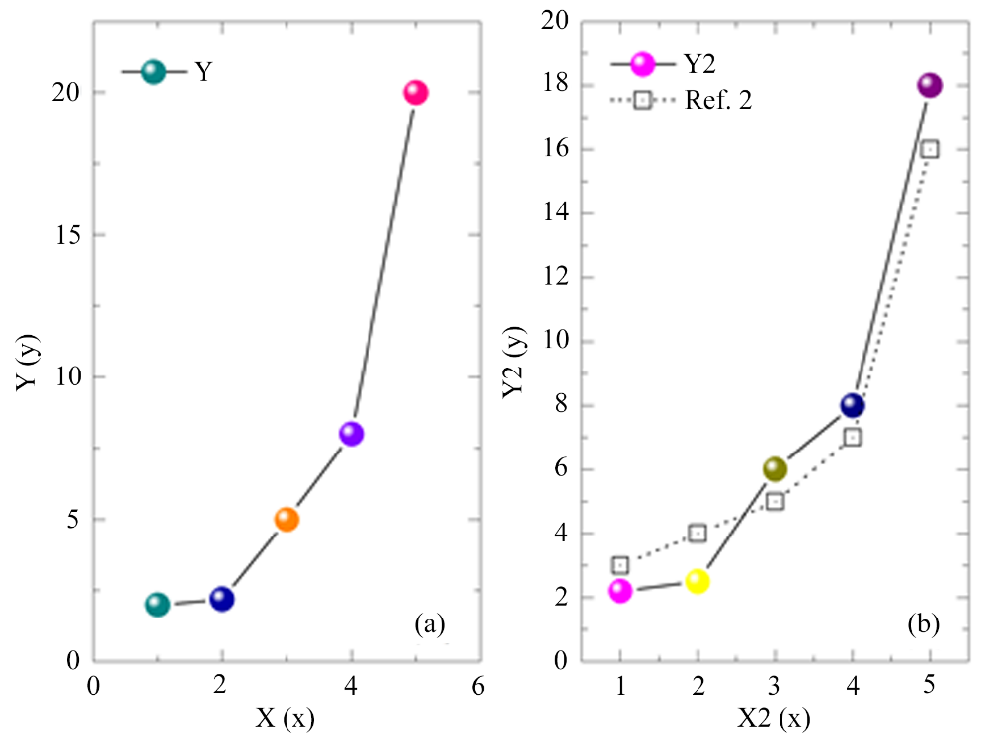
Fig. 2 The relation between Y (a) and Y2 (b) with X.

3. Results and Discussion
Text.....................................................................................................................................................................................................................................................................................................................................................................................................................................................................................................................................................................................................

Table 1 Variation of X and Y.
X (W m^{–1} K^{–2}) | Y (m s^{–2})
1 | 10
2 | 11
3 | 20

4. Conclusion
Text.....................................................................................................................................................................................................................................................................................................................................................................................................................................................................................................................................................................................................

5. Suggestions
Text.....................................................................................................................................................................................................................................................................................................................................................................................................................................................................................................................................................................................................

6. Acknowledgement
Text.....................................................................................................................................................................................................................................................................................................................................................................................................................................................................................................................................................................................................
7. References
[1] J. Geer, J.A.J. Hanraads, R.A. Lupton, The art of writing a scientific article, J. Sci. Commun. 163 (2010) 51 – 59.
[2] W. Strunk, E.B. White, The Elements of Style, fourth ed., Longman, New York, 2000.
[3] W. Strunk, E.B. White, The Elements of Style, Ph.D. Science and Technology, Sakon Nakhon Rajabhat University, Sakon Nakhon, 2000.
[4] G.R. Mettam, L.B. Adams, How to prepare an electronic version of your article, in: B.S. Jones, R.Z. Smith (Eds.), Introduction to the Electronic Age, E-Publishing Inc., New York, 2009, pp. 281 – 304.
[5] How to writing the Manuscript, http://snrujst.snru.ac.th/instructions-for-authors-2, 27 October 2015.
[6] J. Geer, J.A.J. Hanraads, R.A. Lupton, The art of writing a scientific article, Sakon Nakhon Rajabhat University International Conference 2015, Sakon Nakhon Rajabhat University. 24 July 2015, 51 – 59.
[7] J. Geer, J.A.J. Hanraads, R.A. Lupton, The art of writing a scientific article 2, SNRUJST. 100 (2017) 51 – 59.
[8] J. Geer, The art of writing a scientific article 3, SNRUJST. 100 (2017) 60 – 63.
[9] J.A.J. Hanraads, R.A. Lupton, The art of writing a scientific article 4, SNRUJST. 100 (2017) 64 – 69.

